Homework 2

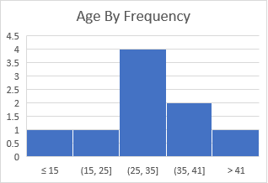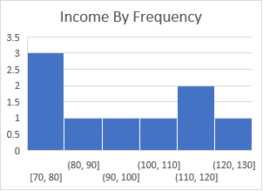

I wanted to choose bin widths that would keep the data clear to visualize. The income data seemed to have no outliers as no use of overflow or underflow bins was necessary. The age data required underflow and overflow bins for its data suggesting it contains outliers.

I used pandas built in histogram plots for this

1. Age Statistics:

Mean 136.7777778

Standard Deviation 323.9235163

Z-scores:

-0.419166164

-0.3450746

-0.338900303

-0.329638857

-0.32346456

-0.314203115

-0.298767372

-0.295680224

2.664895195

1. mean = df["Age"].mean()

print(mean)

std = df["Age"].std()

print(std)

z_score = []

for i in df["Age"]:

x = (i - mean) / std

z_score.append(x)

print(z_score)

I once again leaned on pandas for this

1. A screenshot of a computer

   Description automatically generated